

**Stroke Prevention**

**NATIONAL STROKE ASSOCIATION** **2**

Background 2

AFIB-Stroke Connection 2

Atrial Fibrillation Facts 2

Who is most likely to have Afib? 3

What are the symptoms? 3

Understanding Afib and Stroke 3

People with Afib are 5x more likely to have a stroke. 4

Tools for Patients 5

Impact of Atrial-Fibrillation-Related Stroke 7

Lifestyle Risk Factors 7

Diet and Nutrition 7

Physical Activity 8

Tobacco Use and Smoking 9

Alcohol Use 9

Medical Risk Factors 10

Uncontrollable Risk Factors 10

**MAYO CLINIC** **10**

Prevention 10

Preventive medications 11

**STROKE ASSOCIATION** **12**

Stroke prevention infographics 12

High blood pressure 19

High blood pressure 20

Cigarette smoking 20

Diabetes mellitus 20

Poor diet 21

Physical inactivity and obesity 21

High blood cholesterol 21

Atrial fibrillation 21

Other heart disease 21

Sickle cell disease 21

Peripheral artery disease 21

Carotid or other artery disease 22

Physical activity keeps your mind sharp now and later 22

# [NATIONAL STROKE ASSOCIATION](http://www.stroke.org/understand-stroke/preventing-stroke)

## Background

Certain risk factors can increase your chances of having a stroke. If you have identified personal risk factors, work with your healthcare provider to reduce your personal risk. Prevent stroke happening to you or others by following these guidelines:

* Identify. Review the risk factors and identify your personal risk.
* Reduce your risk factors. Work to reduce your stroke risk through lifestyle changes and if necessary medication.
* Recognize and Respond. Learn to recognize the signs and symptoms of a stroke by memorizing FAST. Respond to the first sight of stroke and help save lives.

## AFIB-Stroke Connection

National Stroke Association’s AFib-Stroke Connection aims to raise awareness about the association between atrial fibrillation (AFib) and the increased risk of stroke by providing educational resources to people with AFib, caregivers and healthcare practitioners.

Atrial fibrillation (AFib) affects an estimated 2.2 million people in the U.S. AFib is a type of irregular heartbeat, often caused when the two upper chambers of the heart beat unpredictably and sometimes rapidly. These irregular heartbeats can cause blood to collect in the heart and potentially form a clot, which can travel to a person’s brain and cause a stroke.

To help raise awareness about the association between AFib and the increased risk of stroke, National Stroke Association has developed the AFib-Stroke Connection. The initiative provides tools to patients and primary care practitioners and their staff to help begin—or continue—discussion about AFib-related stroke between people with AFib and those who provide support and/or healthcare. Learn how the tools can be used by patients or healthcare practitioners.

### Atrial Fibrillation Facts

Know the facts about AFib and prevent stroke from happening to you.

AFib is:

* a leading risk factor for stroke
* more common in people over age 60
* often asymptomatic, making it difficult for people to know that they have it

It's important to note:

* AFib can be successfully managed with the help of a healthcare professional.
* About 15 percent of all people who have strokes also have AFib.
* Knowing about and properly managing your AFib can prevent you from having a stroke.
* Up to 80 percent of strokes in people with AFib can be prevented.

### Who is most likely to have Afib?

You are not alone. An estimated 2.2 million people have been diagnosed with Afib. While it can occur at any age, Afin is more common in older people. About 5% of people 65 years and older and one in every 10 people over 80 have Afib. Afib is more common in people with high blood pressure, heart disease, or diabetes.

### What are the symptoms?

Often, Afib has no obvious symptoms. Some people with Afib describe fluttering, racing or pounding sensations in their chests. Others may experience episodes of dizziness, fainting or lightheadedness. Anyone with these symptoms should visit a healthcare professional to be evaluated for Afib.

### Understanding Afib and Stroke

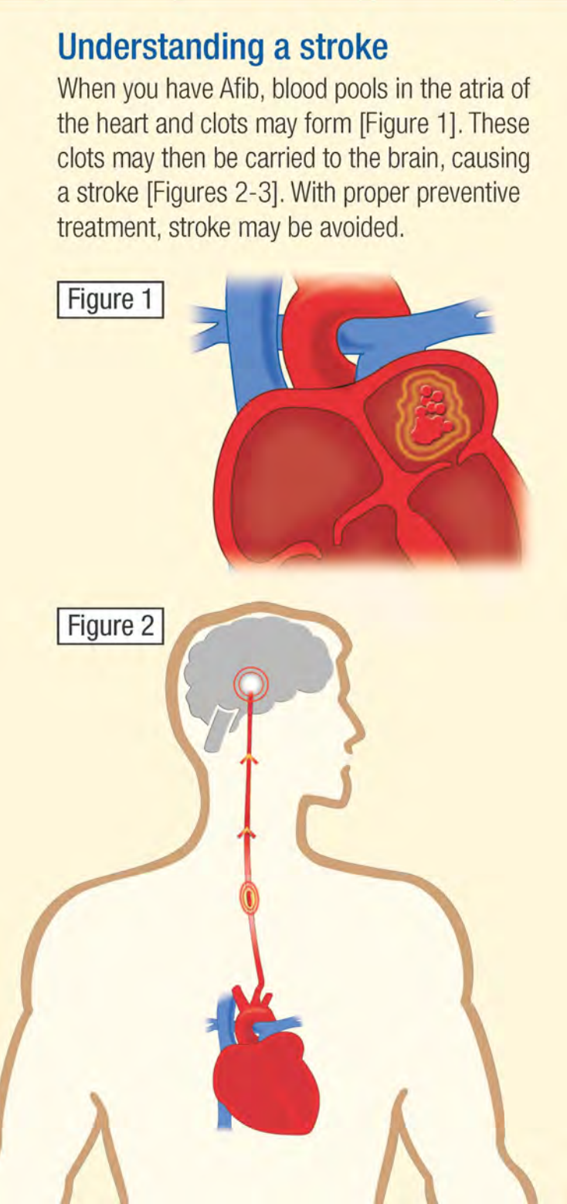

### People with Afib are 5x more likely to have a stroke.

Afib is a major risk factor for stroke. A person with Afib is five times more likely than a person without Afib to have a stroke. However, people who have been diagnosed with Afib have already taken the first step to prevent an Afib-related stroke. 60-80% of strokes in people with Afib can be prevented.

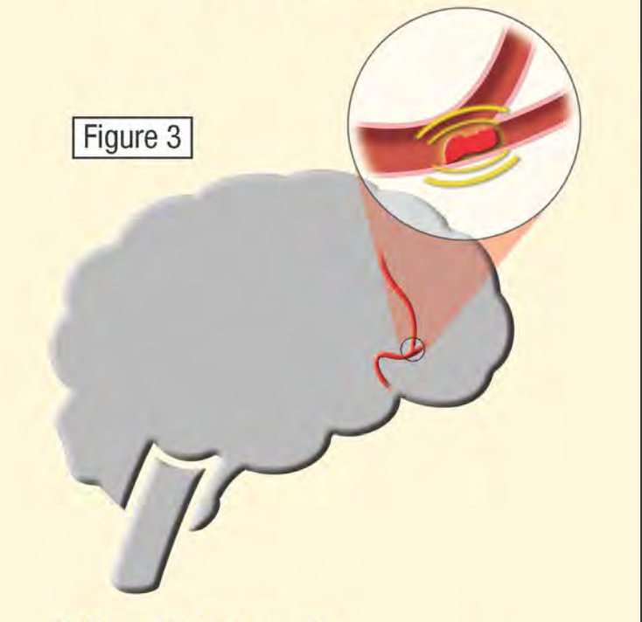

### Tools for Patients

It can be difficult to receive an [atrial fibrillation](http://www.stroke.org/site/PageServer?pagename=afib) (AFib) diagnosis. People with AFib are often overwhelmed by the condition and how it may impact them. Many people with AFib are unaware of the five-times greater risk of stroke as a result of having AFib.

Assess your risk with this [scorecard](http://www.stroke.org/sites/default/files/resources/RiskStrokeScorecard_Eng.pdf):

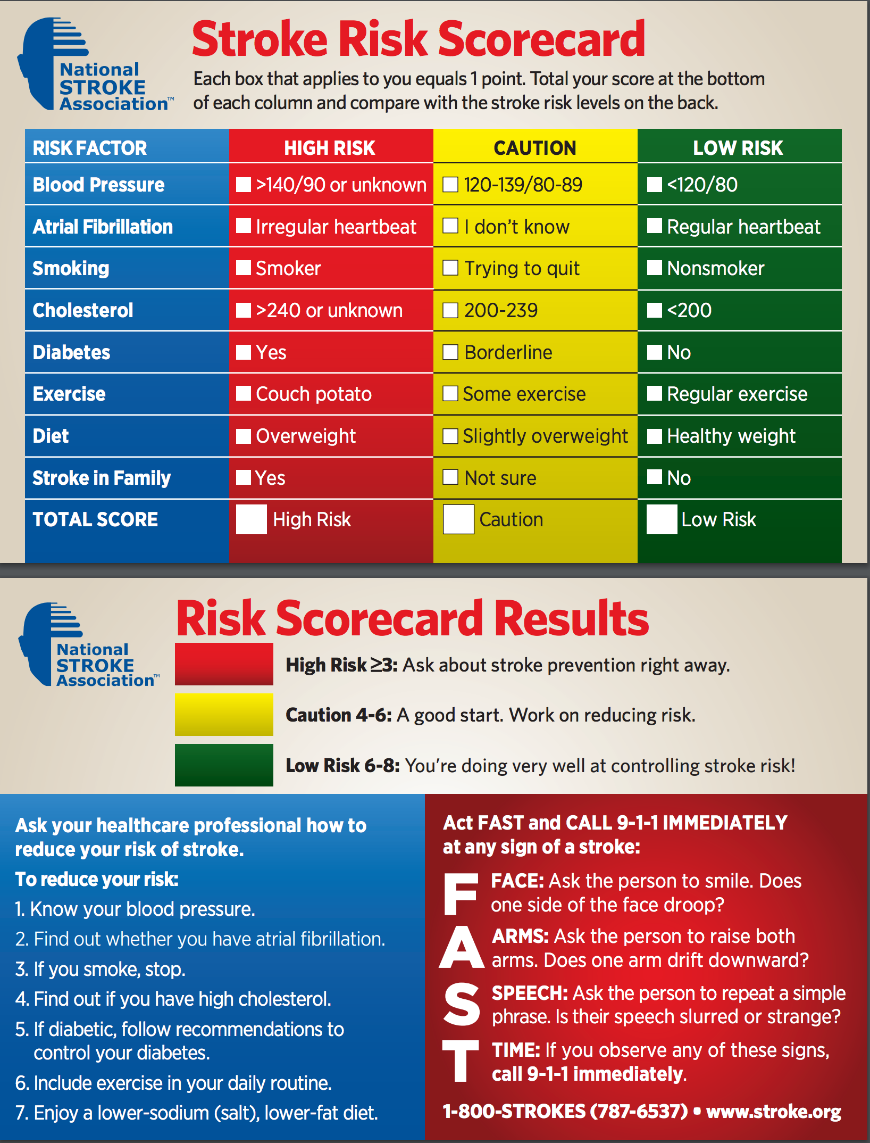

Monitor your risk with this easy to use [tracking card](http://www.stroke.org/sites/default/files/resources/Afib-StrokeConnection_tracking_card.pdf):

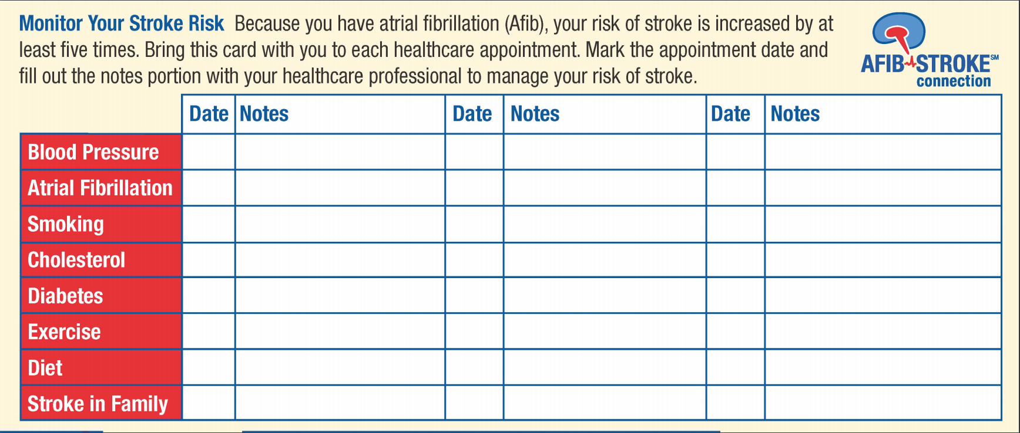

### Impact of Atrial-Fibrillation-Related Stroke

The impact of atrial fibrillation (AFib)-related stroke on patients and caregivers can be devastating. Learn about the findings from a new survey fielded by National Stroke Association, Heart Rhythm Society and Boehringer Ingelheim.

A collaborative survey between National Stroke Association, Heart Rhythm Society, and Boehringer Ingelheim uncovered a critical need to break down barriers and improve communication and education about the link between atrial fibrillation (Afib) and the devastating impact of stroke. Join us for two webinars as we share the survey findings.

http://www.stroke.org/understand-stroke/preventing-stroke/afib-stroke-connection/atrial-fibrillation-impact-stroke-survey

## Lifestyle Risk Factors

Eating habits, physical activity, smoking and drinking are examples of lifestyle stroke risk factors. Lifestyle risk factors are habits or behaviors people choose to engage in. If changed, they can directly affect some medical risk factors by improving them.

### Diet and Nutrition

A healthy diet can help you reduce the risk of chronic diseases, improve your overall health, and help you reach or maintain a healthy weight. Eating healthy includes making informed decisions about food choices and balancing your calories. The Key Recommendations from the [2015-2020 Dietary Guidelines for Americans](https://health.gov/dietaryguidelines/2015/) include the following:

Healthier eating habits include:

* A variety of vegetables from all of the subgroups — dark green, red and orange, legumes (beans and peas), starchy, and other
* Fruits, especially whole fruits
* Grains, at least half of which are whole grains
* Fat-free or low-fat dairy, including milk, yogurt, cheese, and/or fortified soy beverages
* A variety of protein foods, including seafood, lean meats and poultry, eggs, legumes (beans and peas), and nuts, seeds, and soy products
* Oils

Healthier eating habits limit:

* Saturated fats and trans fats, added sugars, and sodium

The following components are of specific concern with individuals needing to stay within specific calorie limits:

* Consume less than 10 percent of calories per day from added sugars
* Consume less than 10 percent of calories per day from saturated fats
* Consume less than 2,300 milligrams (mg) per day of sodium
* Consume alcohol in moderation—up to one drink per day for women and up to two drinks per day for men—and only by adults of legal drinking age.

In addition to the recommendations above, people of all ages—children, adolescents, adults, and older adults— should meet the [Physical Activity Guidelines for Americans](https://health.gov/paguidelines/guidelines/children.aspx) to help promote health and reduce the risk of chronic disease.

Excess weight puts a strain on the entire circulatory system. It can also make people more likely to have high cholesterol, high blood pressure, and diabetes, all of which can increase stroke risk.

### Physical Activity

Physical activity includes anything that gets your body moving. A recent study showed that people who exercise five or more times per week have a reduced stroke risk. The latest recommendations from the Center for Disease Control on [Physical Activity Guidelines](http://www.cdc.gov/physicalactivity/everyone/guidelines/) for adults include the following:

Moderate Activity. 150 minutes of moderate-intensity activity per week (brisk walking, water aerobics, bicycling) and two or more days a week of muscle-strengthening activities.

– OR –

Vigorous Activity. 75 minutes of vigorous-intensity activity per week (jogging, running, swimming laps) and two or more days a week of muscle-strengthening activities.

– OR –

An equivalent mix of moderate- and vigorous-intensity aerobic activity and two or more days a week of muscle-strengthening activities.

Break it up. If you can’t fit a 30-minute activity in at one time, break it up into 10-minute segments. Remember that all physical activity counts.

Make physical activity fun. Walk or bike with a friend, take a dance class, and try different times of the day.

Regular physical activity will improve your overall health and fitness, and reduce your risk for chronic diseases.

### Tobacco Use and Smoking

Smoking doubles the risk of stroke when compared to a nonsmoker. Smoking increases clot formation, thickens blood, and increases the amount of plaque buildup in the arteries. If you smoke, try as hard as possible to stop. Ask your doctor about quit-smoking aids like nicotine patches, counseling, and programs that are available to you. Quitting smoking can be difficult, so don’t give up if you are not successful the first time you try.’

### Alcohol Use

Alcohol use has been linked to stroke in many studies. Drinking too much alcohol can increase blood pressure and the risk of stroke. Aim to drink in moderation – no more than two drinks a day for men and one drink a day for women.

One drink is equal to:

* 12 ounces of beer
* 5 ounces of wine (1 glass)
* 1 ¼ to 1 ½ ounces of liquor

## Medical Risk Factors

High blood pressure, atrial fibrillation (AFib), high cholesterol, diabetes and circulation problems are all or medical risk factors for stroke and can be controlled. Learn more about identifying and treating these medical risk factors.

## Uncontrollable Risk Factors

Some risk factors for stroke are simply not controllable. Learn more about the age, gender, ethnicity, and other factors that are most at risk for stroke.

# [MAYO CLINIC](http://www.mayoclinic.org/diseases-conditions/stroke/manage/ptc-20117267)

## Prevention

Knowing your stroke risk factors, following your doctor's recommendations and adopting a healthy lifestyle are the best steps you can take to prevent a stroke. If you've had a stroke or a transient ischemic attack (TIA), these measures may help you avoid having another stroke. The follow-up care you receive in the hospital and afterward may play a role as well.

Many stroke prevention strategies are the same as strategies to prevent heart disease. In general, healthy lifestyle recommendations include:

* Controlling high blood pressure (hypertension). One of the most important things you can do to reduce your stroke risk is to keep your blood pressure under control. If you've had a stroke, lowering your blood pressure can help prevent a subsequent transient ischemic attack or stroke.
* Exercising, managing stress, maintaining a healthy weight, and limiting the amount of sodium and alcohol you eat and drink are all ways to keep high blood pressure in check.. In addition to recommending lifestyle changes, your doctor may prescribe medications to treat high blood pressure.
* Lowering the amount of cholesterol and saturated fat in your diet. Eating less cholesterol and fat, especially saturated fat and trans fats, may reduce the fatty deposits (plaques) in your arteries. If you can't control your cholesterol through dietary changes alone, your doctor may prescribe a cholesterol-lowering medication.
* Quitting tobacco use. Smoking raises the risk of stroke for smokers and nonsmokers exposed to secondhand smoke. Quitting tobacco use reduces your risk of stroke.
* Controlling diabetes. You can manage diabetes with diet, exercise, weight control and medication.
* Maintaining a healthy weight. Being overweight contributes to other stroke risk factors, such as high blood pressure, cardiovascular disease and diabetes. Weight loss of as little as 10 pounds may lower your blood pressure and improve your cholesterol levels.
* Eating a diet rich in fruits and vegetables. A diet containing five or more daily servings of fruits or vegetables may reduce your risk of stroke. Following the Mediterranean diet, which emphasizes olive oil, fruit, nuts, vegetables and whole grains, may be helpful.
* Exercising regularly. Aerobic or "cardio" exercise reduces your risk of stroke in many ways. Exercise can lower your blood pressure, increase your level of high-density lipoprotein cholesterol, and improve the overall health of your blood vessels and heart. It also helps you lose weight, control diabetes and reduce stress. Gradually work up to 30 minutes of activity — such as walking, jogging, swimming or bicycling — on most, if not all, days of the week.
* Drinking alcohol in moderation, if at all. Alcohol can be both a risk factor and a protective measure for stroke. Heavy alcohol consumption increases your risk of high blood pressure, ischemic strokes and hemorrhagic strokes. However, drinking small to moderate amounts of alcohol, such as one drink a day, may help prevent ischemic stroke and decrease your blood's clotting tendency. Alcohol may also interact with other drugs you're taking. Talk to your doctor about what's appropriate for you.
* Treating obstructive sleep apnea, if present. Your doctor may recommend an overnight oxygen assessment to screen for obstructive sleep apnea (OSA). If OSA is detected, it may be treated by giving you oxygen at night or having you wear a small device in your mouth.
* Avoiding illicit drugs. Certain street drugs, such as cocaine and methamphetamines, are established risk factors for a TIA or a stroke. Cocaine reduces blood flow and can cause narrowing of arteries.

## Preventive medications

If you've had an ischemic stroke or TIA, your doctor may recommend medications to help reduce your risk of having another stroke. These include:

* Anti-platelet drugs. Platelets are cells in your blood that initiate clots. Anti-platelet drugs make these cells less sticky and less likely to clot. The most commonly used anti-platelet medication is aspirin. Your doctor can help you determine the right dose of aspirin for you.
* Your doctor may also consider prescribing Aggrenox, a combination of low-dose aspirin and the anti-platelet drug dipyridamole, to reduce the risk of blood clotting. If aspirin doesn't prevent your TIA or stroke, or if you can't take aspirin, your doctor may instead prescribe an anti-platelet drug such as clopidogrel (Plavix).
* Anticoagulants. These drugs, which include heparin and warfarin (Coumadin), reduce blood clotting. Heparin is fast-acting and may be used over a short period of time in the hospital. Slower acting warfarin may be used over a longer term.
* Warfarin is a powerful blood-thinning drug, so you'll need to take it exactly as directed and watch for side effects. Your doctor may prescribe these drugs if you have certain blood-clotting disorders, certain arterial abnormalities, an abnormal heart rhythm or other heart problems. Other newer blood thinners may be used if your TIA or stroke was caused by an abnormal heart rhythm.

# STROKE ASSOCIATION

## Stroke prevention infographics

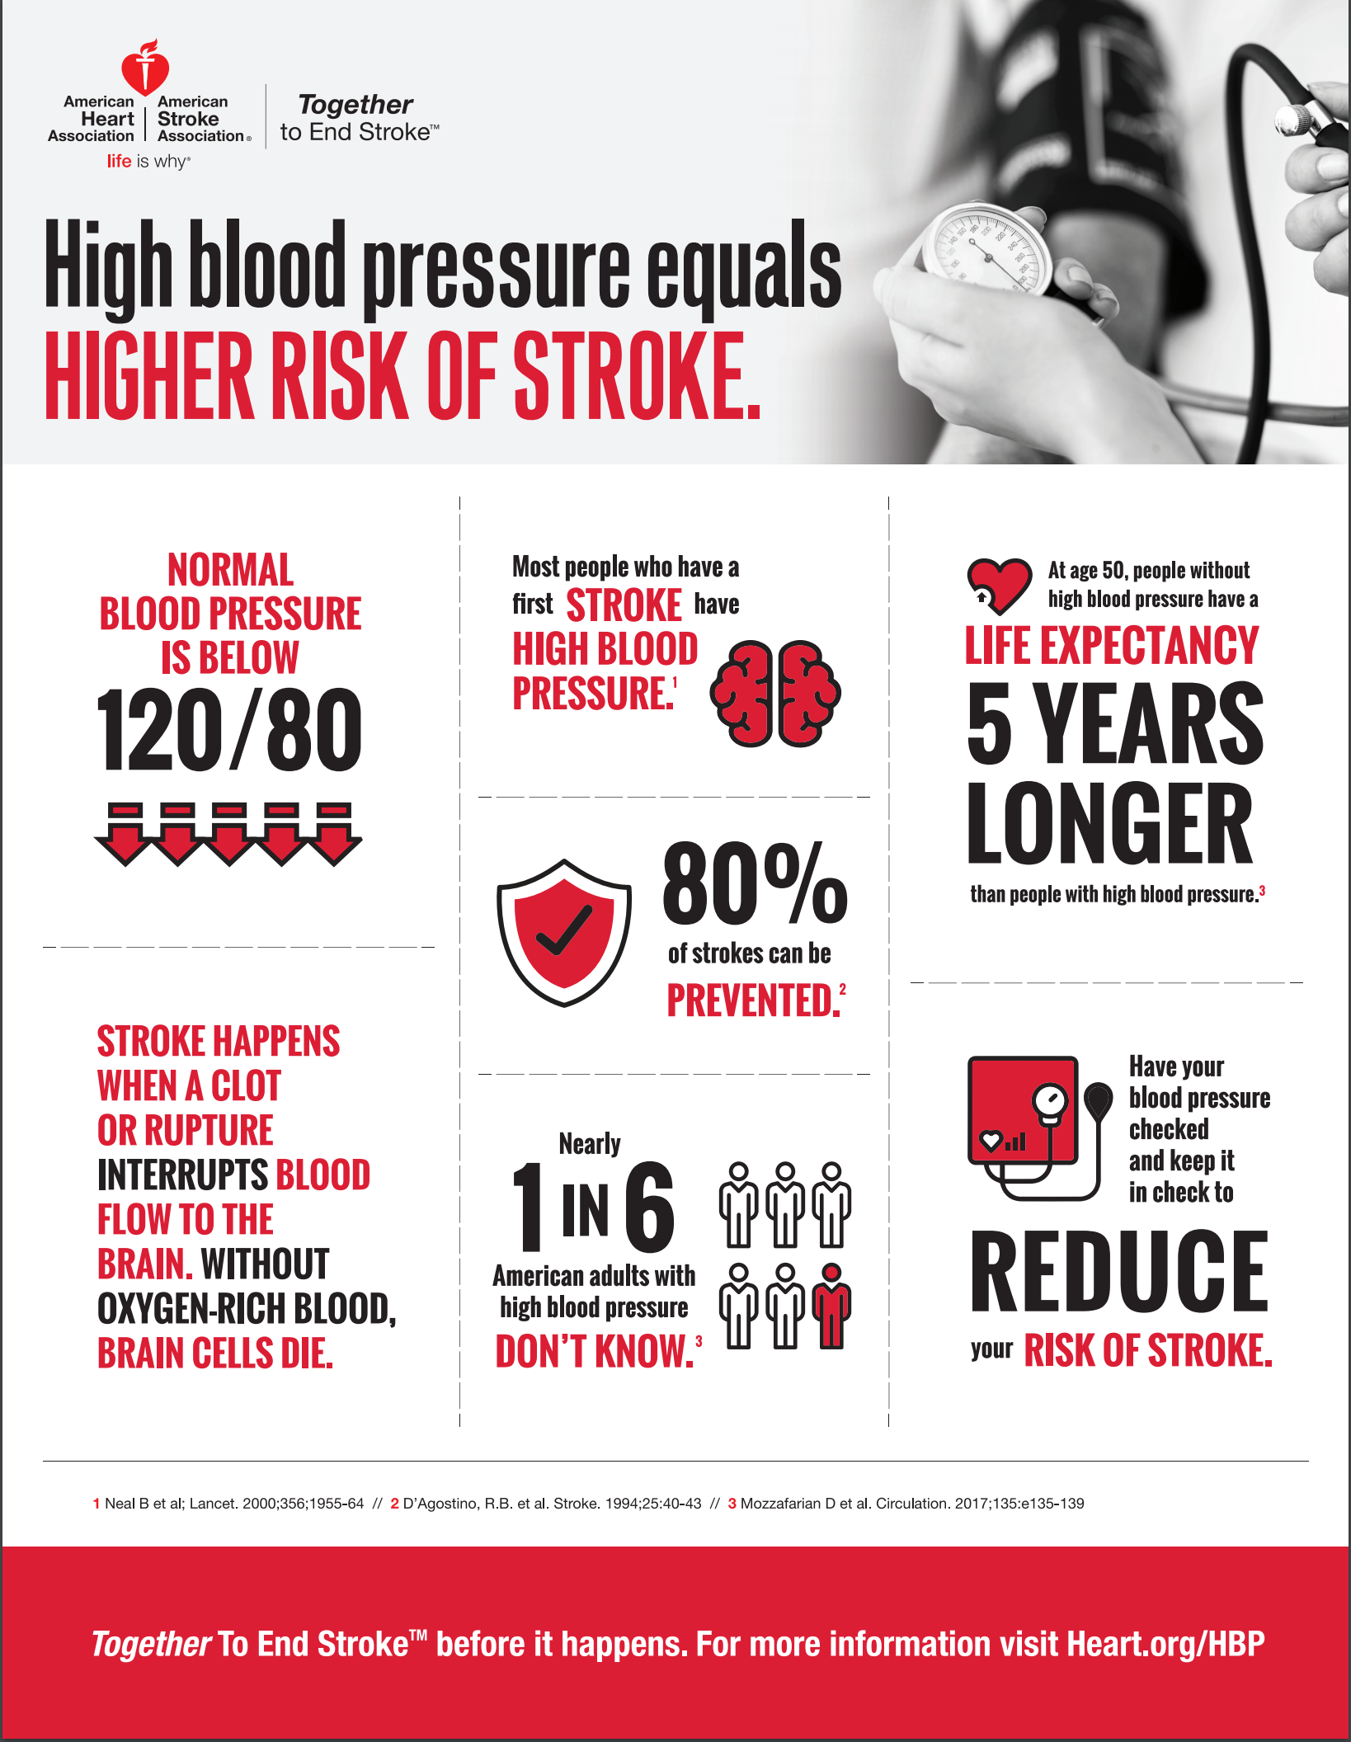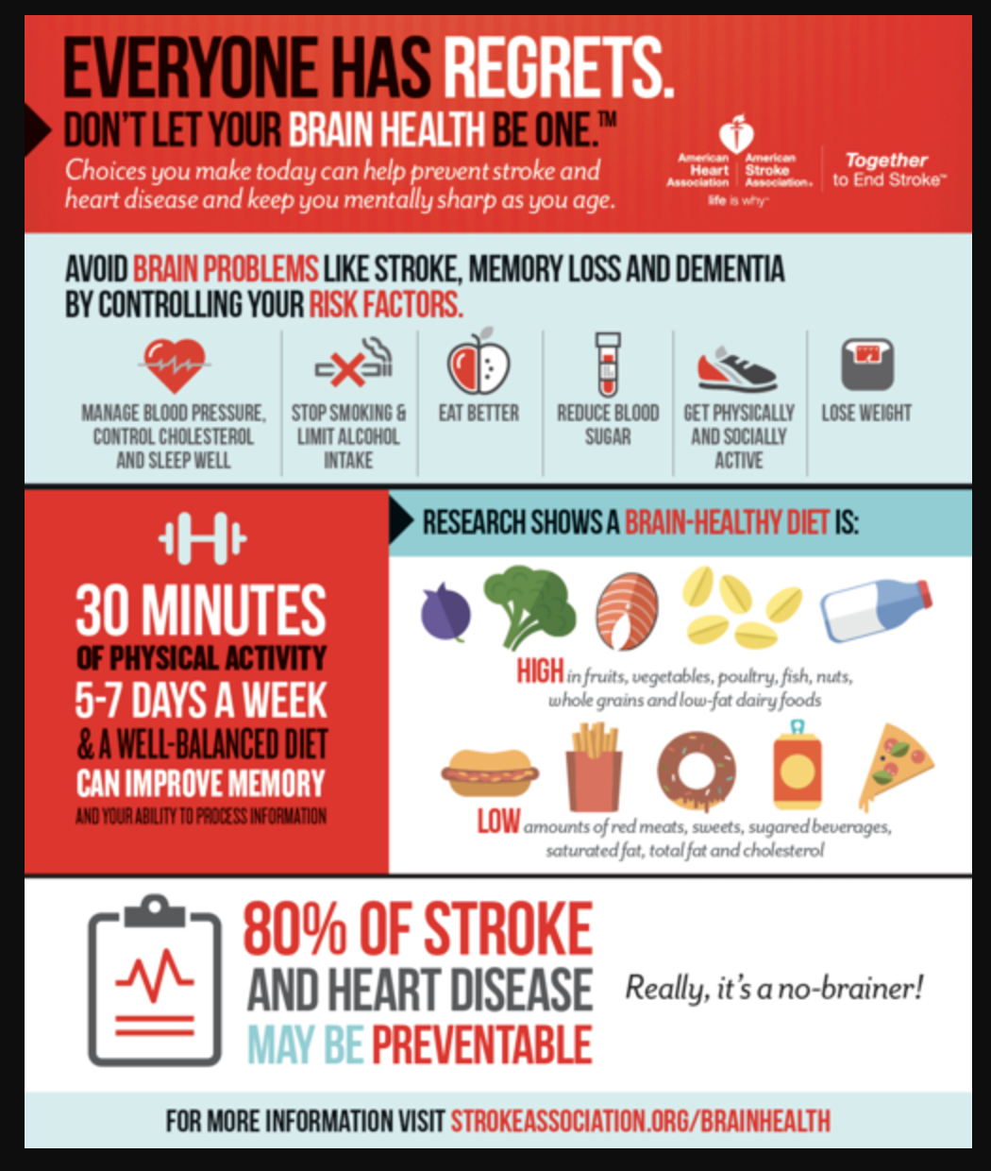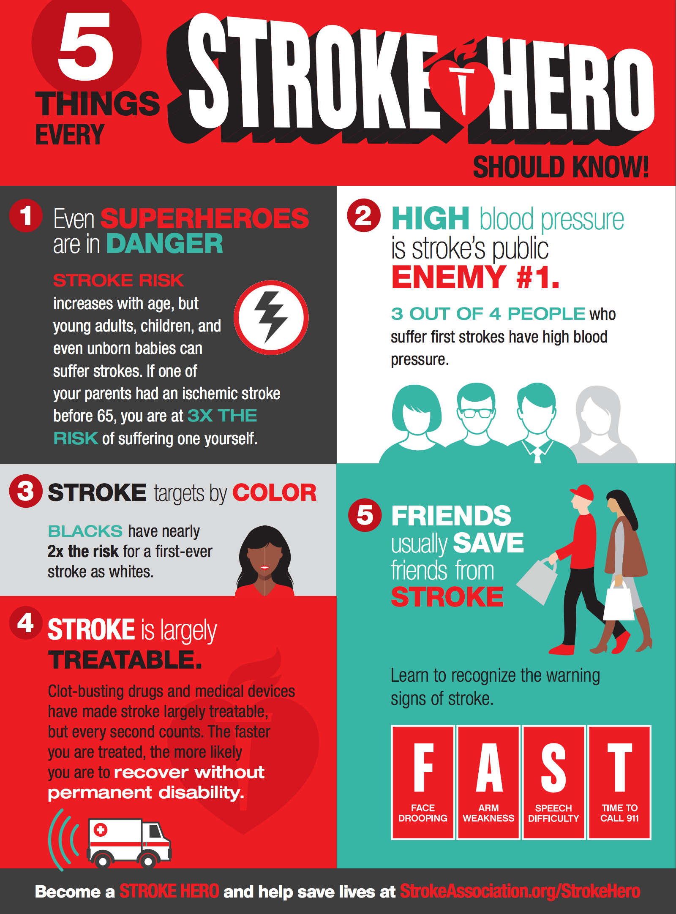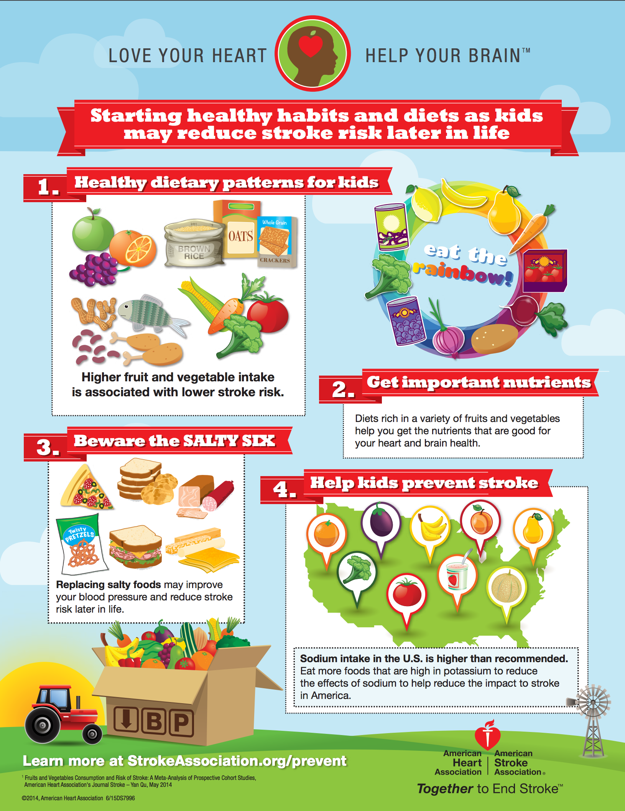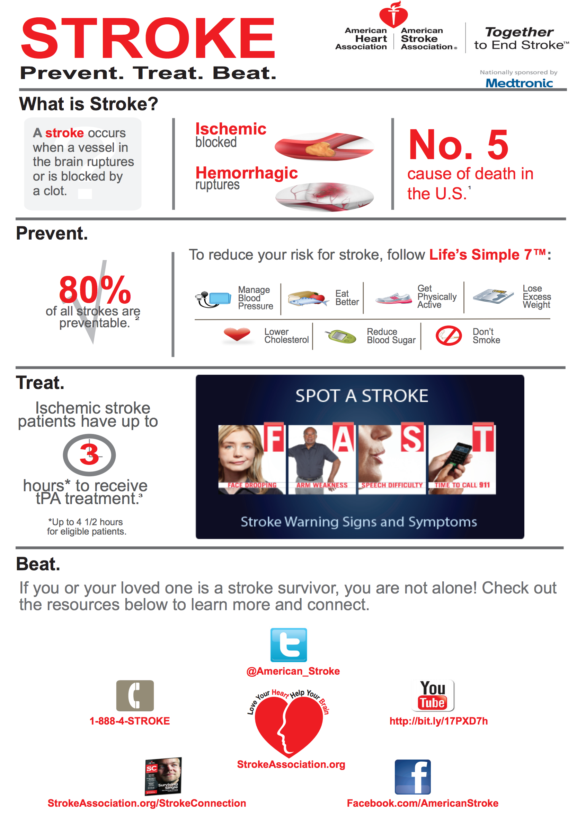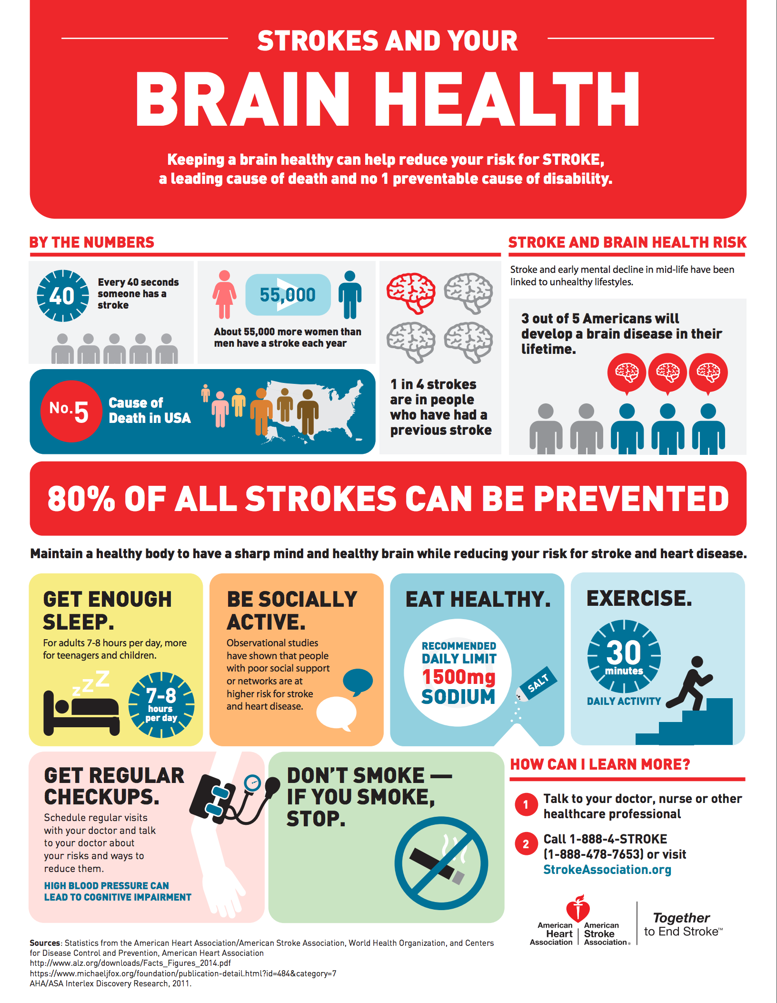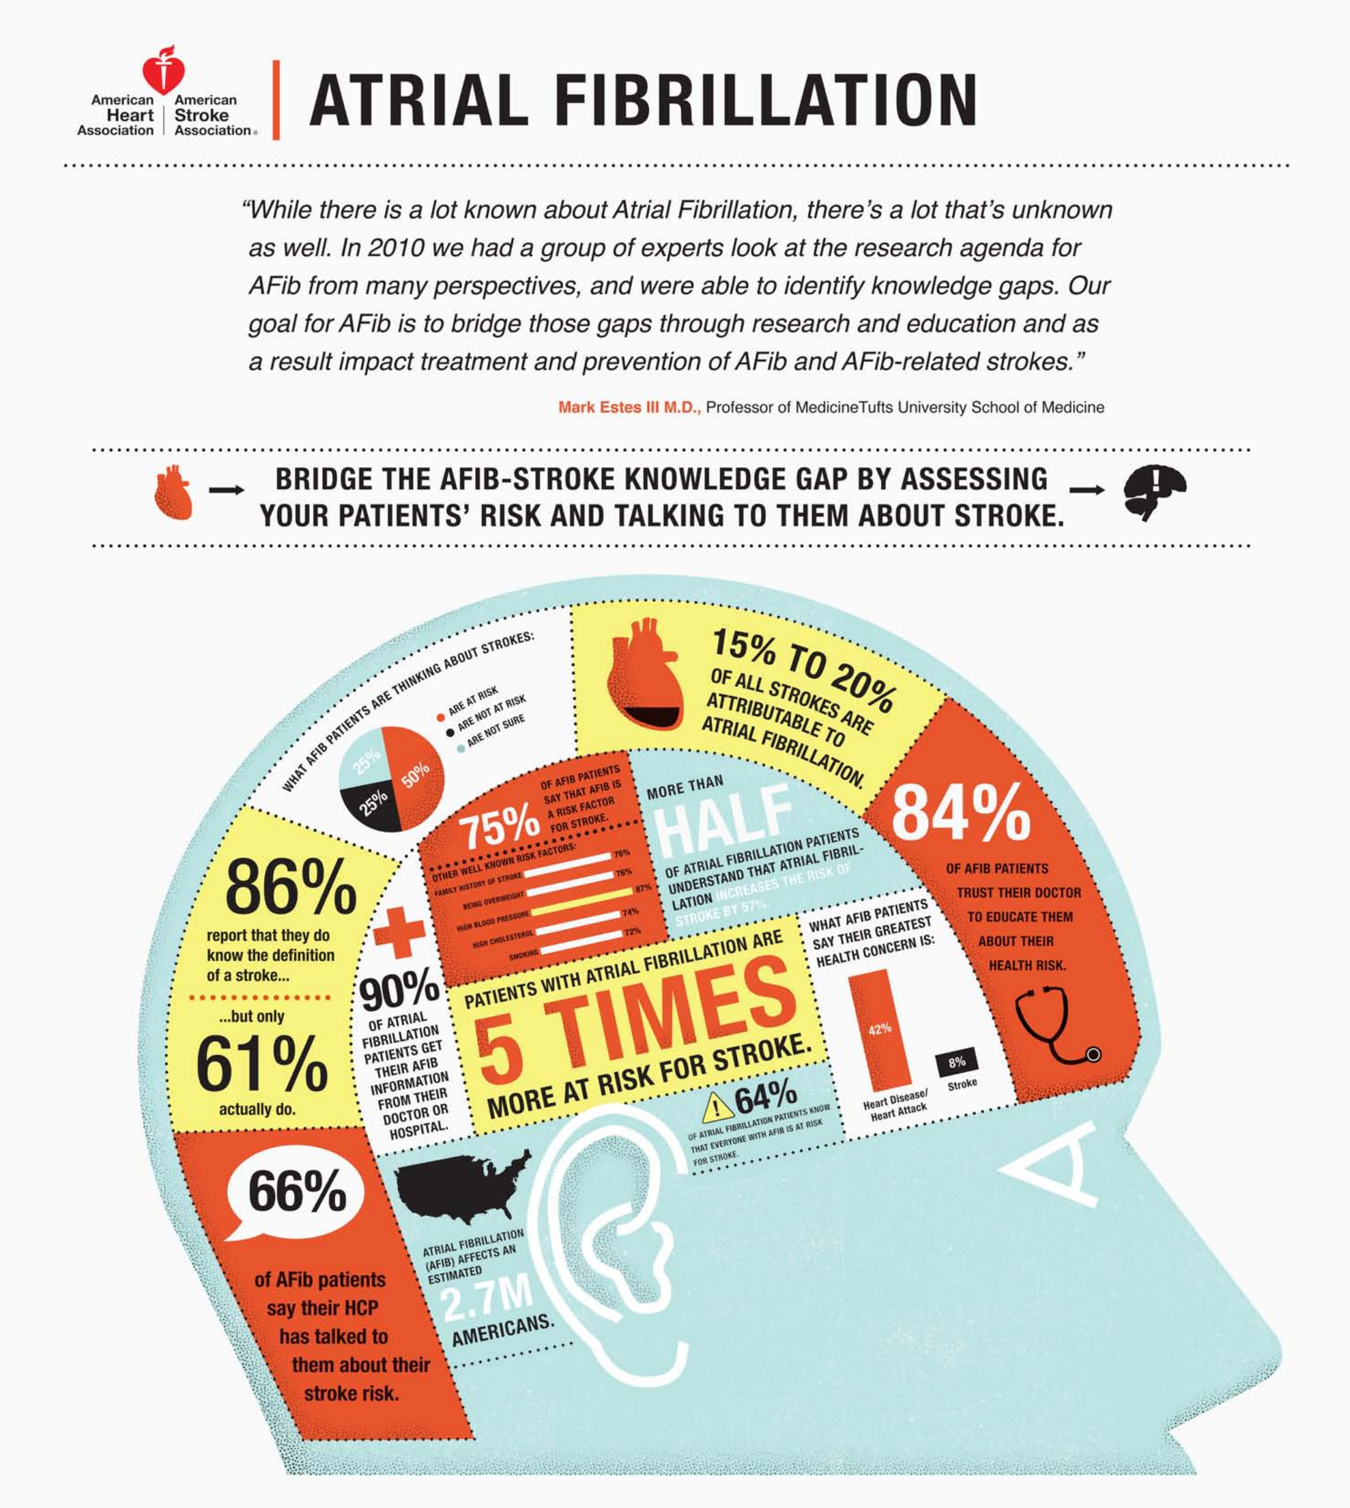

## High blood pressure

Did you know that 80% of strokes are preventable? That means there are things you can do to reduce your risk. The most important controllable risk factor is high blood pressure.

High blood pressure can damage blood vessels in the brain, increasing the chances of clots or ruptures. If a clot or rupture interferes with the flow of oxygen-rich blood to the brain, a stroke can occur. One in three U.S. adults has high blood pressure, and it often goes untreated. The key is getting your blood pressure checked. Because high blood pressure has no obvious symptoms, checking is the only way to find out.

Your healthcare provider can recommend ways to lower your blood pressure, including exercise and maintaining a healthy weight.

Medication is sometimes prescribed to treat high blood pressure, but it only works if you take it, so make sure you don’t skip any doses.

## High blood pressure

HBP is the No. 1 cause of stroke and the most important controllable risk factor for stroke. People who are overweight or obese, over age 35, have a family history of HBP, African Americans, pregnant women, and those who are physically inactive, eat too much salt and/or drink too much alcohol are at higher risk for HBP.

Of all people with high blood pressure, more than 20 percent are unaware of their condition. Are you one of them? If you don’t know, see a healthcare professional to be tested.

How can you control your blood pressure?

* Eat a better diet, which may include reducing salt intake.
* Engage in regular physical activity.
* Maintain a healthy weight.
* Manage stress.
* Avoid tobacco smoke.
* Take your medication as prescribed.
* If you drink alcohol, limit your intake (no more than one drink per day for women and two drinks per day for men).

## Cigarette smoking

The nicotine and carbon monoxide in cigarette smoke damage the cardiovascular system in many ways. The use of oral contraceptives combined with cigarette smoking greatly increases stroke risk.

## Diabetes mellitus

Many people with diabetes also have high blood pressure, high blood cholesterol and are overweight. This increases their risk even more. Though diabetes is treatable, the presence of the disease still increases your risk of stroke.

## Poor diet

Diets high in saturated fat, trans fat and cholesterol can raise blood cholesterol levels. Diets high in sodium (salt) can contribute to increased blood pressure. Diets with excess calories can contribute to obesity. But a diet that includes five or more servings of fruits and vegetables per day may reduce stroke risk.

## Physical inactivity and obesity

Being inactive, obese or both can increase your risk of high blood pressure, high blood cholesterol, diabetes, heart disease and stroke. So go on a brisk walk, take the stairs and do whatever you can to make your life more active. Try to get a total of at least 30 minutes of activity on most or all days.

## High blood cholesterol

It also appears that low HDL (“good”) cholesterol is a risk factor for stroke in men, but more data are needed to verify its effect in women.

## Atrial fibrilation

The heart’s upper chambers quiver instead of beating effectively, which can let the blood pool and clot. If a clot breaks off, enters the bloodstream and lodges in an artery leading to the brain, a stroke results.

## Other heart disease

People with coronary heart disease or heart failure have a higher risk of stroke than those with hearts that work normally. Dilated cardiomyopathy (an enlarged heart), heart valve disease and some types of congenital heart defects also raise the risk of stroke.

## Sickle cell disease

The genetic disorder mainly affects AfricanAmerican and Hispanic children. “Sickled” red blood cells are less able to carry oxygen to tissues and organs. These cells also tend to stick to blood vessel walls, which can block arteries to the brain and cause a stroke.

## Peripheral artery disease

is the narrowing of blood vessels carrying blood to leg and arm muscles. It’s caused by fatty buildups of plaque in artery walls. People with peripheral artery disease have a higher risk of carotid artery disease, which raises their risk of stroke.

## Carotid or other artery disease

The carotid arteries in your neck supply blood to your brain. A carotid artery narrowed by fatty deposits from atherosclerosis may become blocked by a blood clot. Carotid artery disease is also called carotid artery stenosis.

## Physical activity keeps your mind sharp now and later

Having a sharp brain well into your senior years starts with healthy habits — like exercising — in your 20s’.

“Young people might not consider the immediate and long-term positive effects that exercise can have on their brain, but exercise helps to keep our brains and hearts strong so we can be sharp and independent well into our golden years,” said Mitchell Elkind, M.D., M.S., Associate Professor of Neurology and Epidemiology in Columbia University’s Stroke Division in New York, New York.

Results from recent research support Elkind’s point: In a study of 120 women ages 18 to 35, researchers found that higher fitness levels are linked to better attention, learning, working memory and problem solving.

Another study found that people ages 18 to 30 who had high levels of blood pressure, fasting blood sugar and cholesterol at the study’s start or 10 years into it scored much lower on cognitive testing at the study’s end, when they were an average 50 years old. The findings suggest that these risk factors that cause stroke and heart disease can also cause dementia and build up over the years.

“[Risk factors](http://www.strokeassociation.org/STROKEORG/AboutStroke/UnderstandingRisk/Understanding-Stroke-Risk_UCM_308539_SubHomePage.jsp) for stroke, heart disease and other illnesses like dementia start as early as our 20s and 30s and builds over time, causing mental and/or physical decline as we age,” Elkind said.

You don’t have to exercise vigorously. In fact, you can benefit from any regular physical activity, including something as simple as walking — which is free, safe and easy.